Welcome to Lab 5! Today, we are first going to learn about feature selection and getting rid of data with low variance and then about overfitting.
1 | Iris Dataset
We are going to first create a copy of the iris dataset and then we will manually add in random variance to test a couple useful tools.
from sklearn.datasets import load_iris

import pandas as pd

x, y = load_iris(return_X_y=True)

df = pd.DataFrame(x)
df.head()

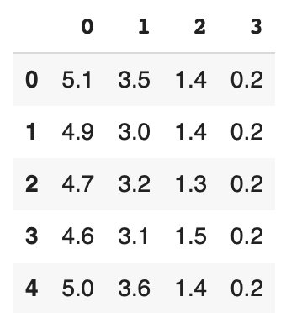

As expected, it’s the iris dataset we’ve been working with for a while now.

1.1 | Simulating Random Variance
We need to generate a lot of random data in order to run through some feature selection processes, so let’s import random:
import random
And we are going to make 150 random numbers with pretty low variance (between 65.0 and 65.2). This is to simulate us having a bad feature in our dataset, such as temperature.
random_ns = []

for i in range(150):
new_random_number = random.uniform(65, 65.2)
random_ns.append(new_random_number)
random_ns = pd.DataFrame(random_ns)

print(random_ns)

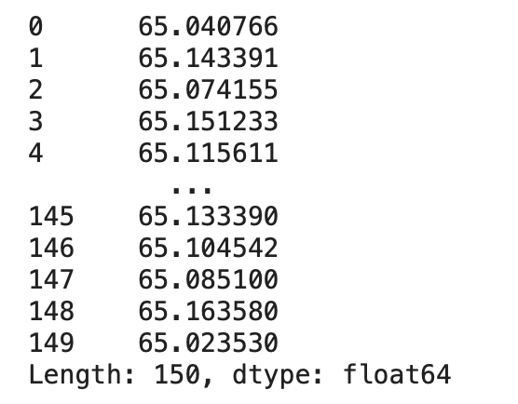

TAKE QUESTIONS

Excellent. Now let’s put the two things together! We will add these random numbers into a new temp column of the dataframe:
names = ["sepal length", "sepal width", "pedal length", "pedal width"]
df.columns = names
df.head()
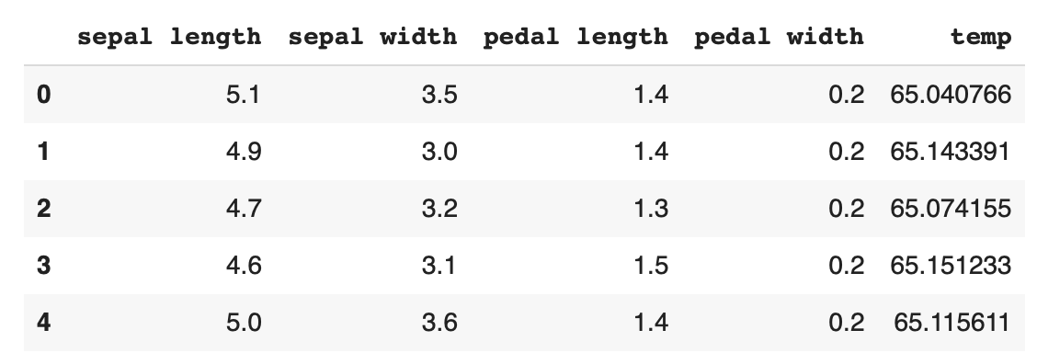

df["temp"] = random_ns
df.head()

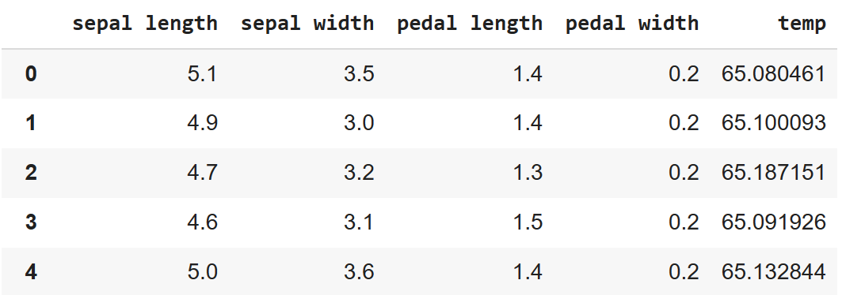

And done!

2 | Feature Selection
Hypothetically, let’s assume the new dataframe we have right now is what our input data looks like, and we aren’t aware that it has random, meaningless data in it in the 5th column. So how do we filter out any potentially bad data?
import seaborn as sns
import matplotlib.pyplot as plt

plt.figure()
cor = df.corr()
sns.heatmap(cor, annot=True)
plt.show()
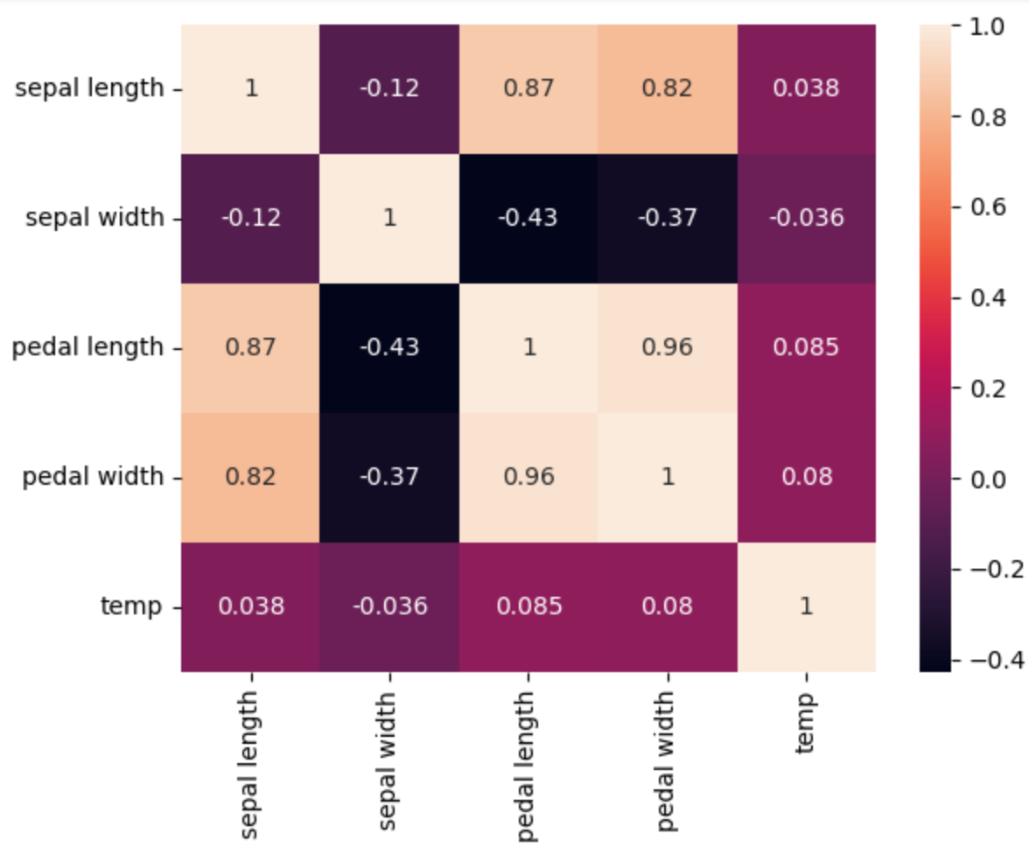
2.1 | Variance Threshold
The first tool we will use is variance threshold. This tool removes data that doesn’t vary enough (aka useless data).
from sklearn.feature_selection import VarianceThreshold
filter = VarianceThreshold(0.1)
cleaned_data = filter.fit_transform(df)
But this cleaned data is not in the pandas dataframe format, so let’s convert it back and take a look at it:
cleaned_data_df = pd.DataFrame(cleaned_data)
cleaned_data_df.head()
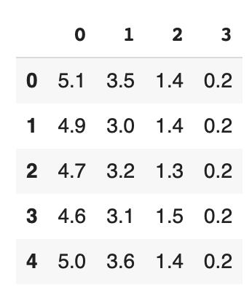
Our old labels aren’t there either, but that’s ok. More importantly, notice how the rightmost column of bad data that we added in part 1 was removed by the variance threshold tool (look back at the final step in section 1.1 if you want to compare).
2.2 | Select K Best
Now let’s use the select k best tool. This tool only keeps the top k features and removes the rest. As a reminder, our df still has the column of bad data in it, feel free to print it out again to verify.
print(chi2(df, y))

from sklearn.feature_selection import SelectKBest, chi2
filter = SelectKBest(chi2, k=4)
# reminder: y comes from the load_iris() function from a while ago
res = filter.fit_transform(df, y)

And let’s convert it to a dataframe:
res = pd.DataFrame(res)
res.head()
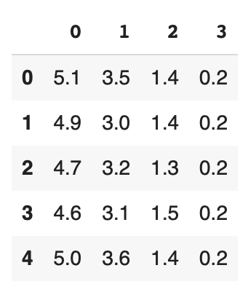

Once again, the bad data has been removed, leaving only the k=4 features that the algorithm deemed best.

3 | Modified Iris Dataset
Ok, we just learned two tools that can help us do feature selection. Let’s try them out in a new example.
Download the modified_iris.csv from https://aibridgecamp.github.io/classes.html.
- Fit a logistic regression classifier to this current data, using species as
- Run through the feature selection process again
- Fit a logistic regression classifier to this new data, once again use species as
Bonus Task: Try different combinations of hyperparameters and number of features (SelectKBest) and try to get as high an accuracy as possible.

